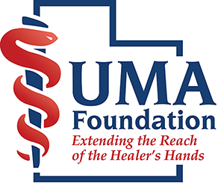

The UMA Foundation certifies

has participated in the live activity titled,
(Title of the Activity/Event),
on (Date) in (Location of event).

This activity has been planned and implemented in accordance with the accreditation requirements and policies of the Utah Medical Association through the joint providership of the UMA Foundation and the (organization’s name). The UMA Foundation is accredited by the Utah Medical Association to provide continuing medical education for physicians.

The UMA Foundation designates this live activity for a maximum of (# of credits earned) AMA PRA Category 1 Credits™. Physicians should claim only the credit commensurate with the extent of their participation in the activity.

